8 | Pharmacokinetics:  Basic Considerations
The duration of drug therapy ranges from a single dose of a drug taken for relieving an acute condition such as headache to drugs taken life-long for chronic conditions such as hypertension, diabetes, asthma or epilepsy. The frequency of administration of a drug in a particular dose is called as dosage regimen. Depending upon the therapeutic objective to be attained, the duration of drug therapy and the dosage regimen are decided.
Rational and optimal therapy with a drug depends upon –
- Choice of a suitable drug, and
- A balance between the therapeutic and the toxic effects.
Both, the therapeutic and the toxic effects, depend upon the concentration of drug at the site of action which is difficult to measure. However, it corresponds to a specific concentration of drug in plasma which can be measured with accuracy. The drug fails to elicit a therapeutic response when the concentration is below the effective level and precipitates adverse reactions when above the toxic level. The plasma drug concentration between these two limits is called as the therapeutic concentration range or therapeutic window (the ratio of maximum safe concentration to minimum effective concentration of the drug is called as the therapeutic index). Thus, in order to achieve therapeutic success, plasma concentration of the drug should be maintained within the therapeutic window. For this, knowledge is needed not only of the mechanisms of drug absorption, distribution, metabolism and excretion, but also of the kinetics of these processes i.e. pharmacokinetics. Pharmacokinetics is defined as the kinetics of drug absorption, distribution, metabolism and excretion (KADME) and their relationship with the pharmacological, therapeutic or toxicological response in man and animals. There are two aspects of pharmacokinetic studies –
- Theoretical aspect – which involves development of pharmacokinetic models to predict drug disposition after its administration. Statistical methods are commonly applied to interpret data and assess various parameters.
- Experimental aspect – which involves development of biological sampling techniques, analytical methods for measurement of drug (and metabolites) concentration in biological samples and data collection and evaluation.

Several relevant terms can now be defined –
- Clinical Pharmacokinetics is defined as the application of pharmacokinetic principles in the safe and effective management of individual patient.
- Population Pharmacokinetics is defined as the study of pharmacokinetic differences of drugs in various population groups.
- Toxicokinetics is defined as the application of pharmacokinetic principles to the design, conduct and interpretation of drug safety evaluation studies.

Plasma Drug Concentration-Time Profile
A direct relationship exists between the concentration of drug at the biophase (site of action) and the concentration of drug in plasma. Two categories of parameters can be evaluated from a plasma concentration time profile –
- Pharmacokinetic parameters, and
- Pharmacodynamic parameters.
A typical plasma drug concentration-time curve obtained after a single oral dose of a drug and showing various pharmacokinetic and pharmacodynamic parameters is depicted in Fig. 8.1. Such a profile can be obtained by measuring the concentration of drug in plasma samples taken at various intervals of time after administration of a dosage form and plotting the concentration of drug in plasma (Y-axis) versus the corresponding time at which the plasma sample was collected (X-axis).
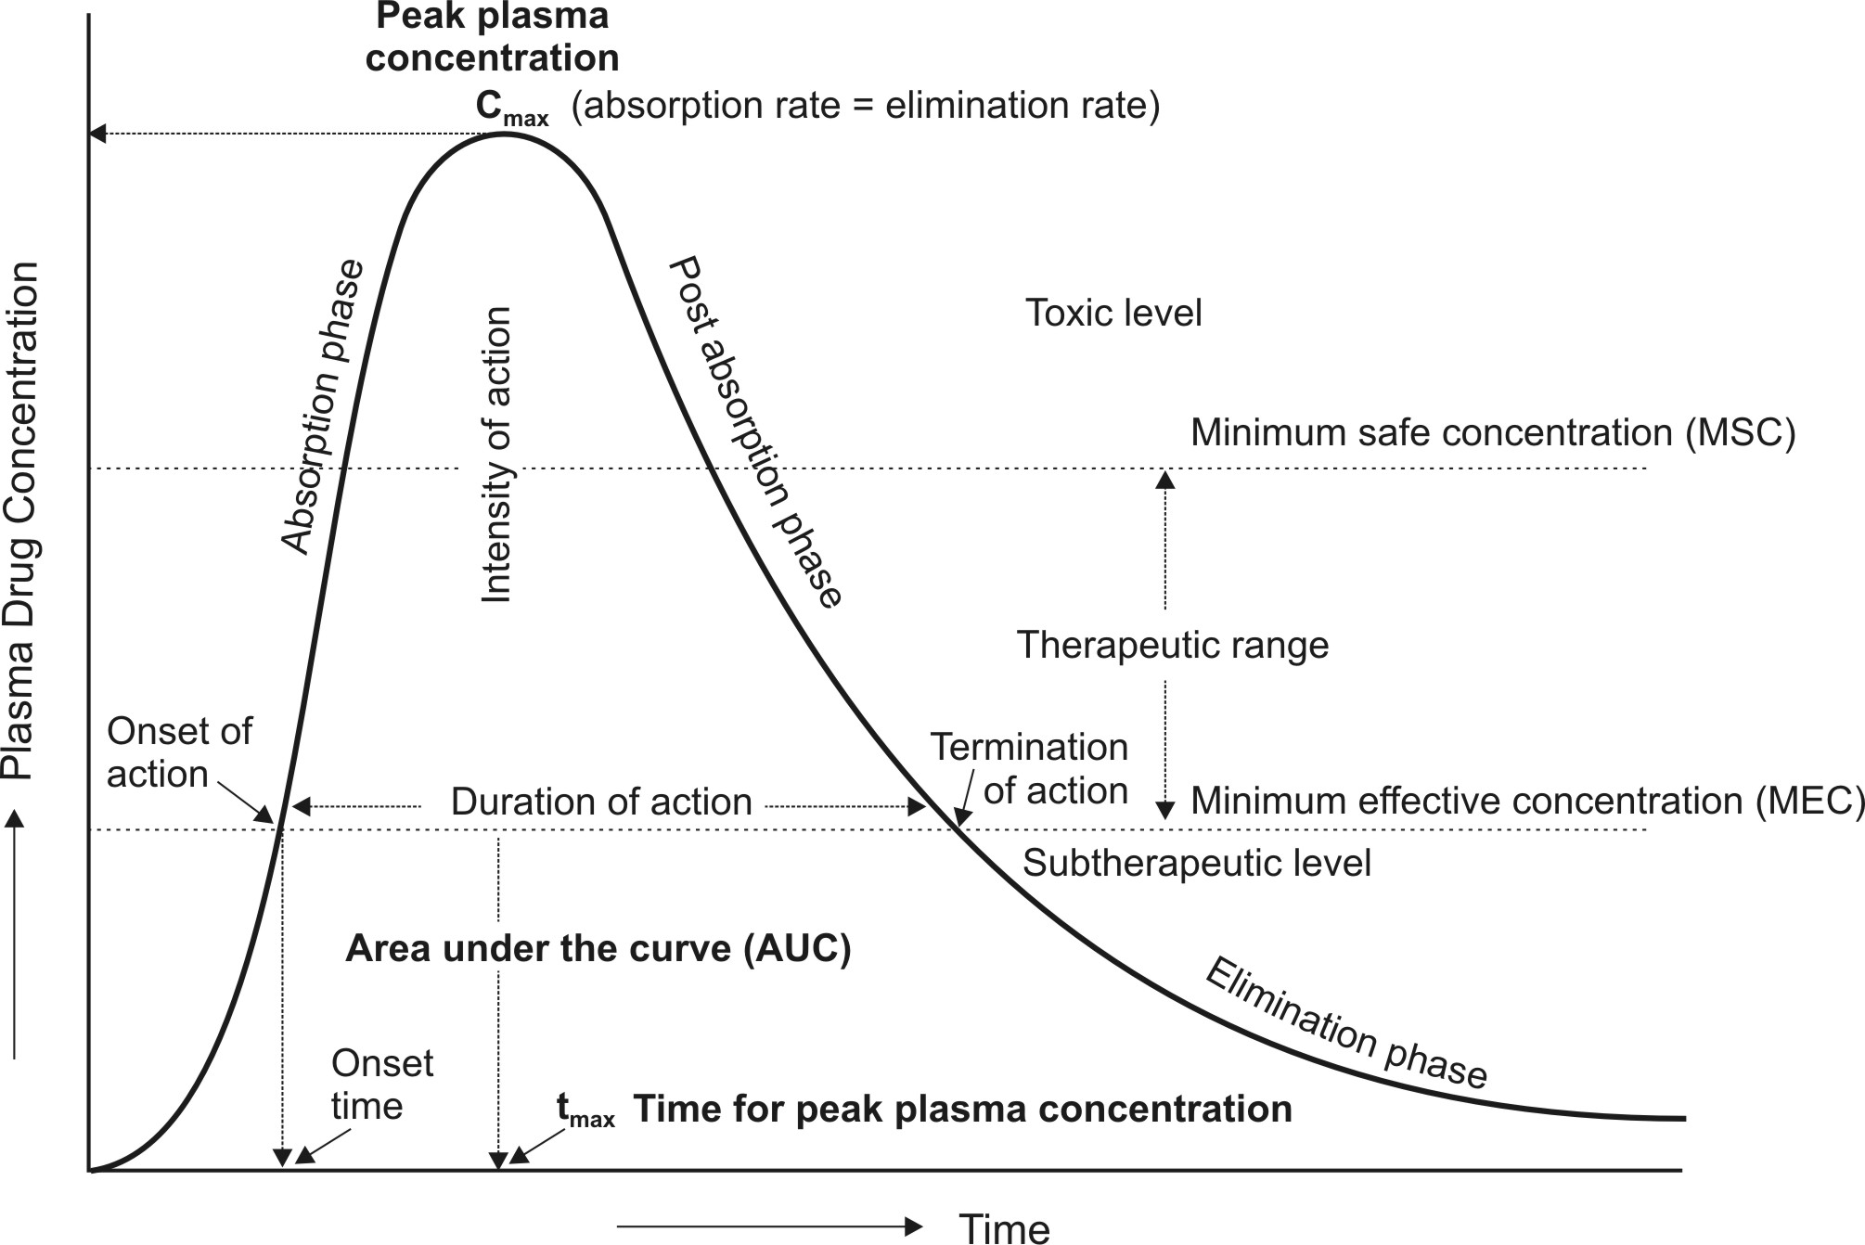
Fig. 8.1. A typical plasma concentration-time profile showing pharmacokinetic and pharmacodynamic parameters, obtained after oral administration of single dose of a drug.

Pharmacokinetic Parameters
The three important pharmacokinetic parameters that describe the plasma level-time curve and useful in assessing the bioavailability of a drug from its formulation are –
1. Peak Plasma Concentration (Cmax)
The point of maximum concentration of drug in plasma is called as the peak and the concentration of drug at peak is known as peak plasma concentration. It is also called as peak height concentration and maximum drug concentration. Cmax is expressed in mcg/ml. The peak plasma level depends upon –
- The administered dose
- Rate of absorption, and
- Rate of elimination.
The peak represents the point of time when absorption rate equals elimination rate of drug. The portion of curve to the left of peak represents absorption phase i.e. when the rate of absorption is greater than the rate of elimination. The section of curve to the right of peak generally represents elimination phase i.e. when the rate of elimination exceeds rate of absorption. Peak concentration is often related to the intensity of pharmacological response and should ideally be above minimum effective concentration (MEC) but less than the maximum safe concentration (MSC).
2. Time of Peak Concentration (tmax)
The time for drug to reach peak concentration in plasma (after extravascular administration) is called as the time of peak concentration. It is expressed in hours and is useful in estimating the rate of absorption. Onset time and onset of action are dependent upon tmax. This parameter is of particular importance in assessing the efficacy of drugs used to treat acute conditions like pain and insomnia which can be treated by a single dose.
3. Area Under the Curve (AUC)
It represents the total integrated area under the plasma level-time profile and expresses the total amount of drug that comes into the systemic circulation after its administration. AUC is expressed in mcg/ml X hours. It is the most important parameter in evaluating the bioavailability of a drug from its dosage form as it represents the extent of absorption. AUC is also important for drugs that are administered repetitively for the treatment of chronic conditions like asthma or epilepsy.

Pharmacodynamic Parameters
The various pharmacodynamic parameters are –
1. Minimum Effective Concentration (MEC)
It is defined as the minimum concentration of drug in plasma required to produce the therapeutic effect. It reflects the minimum concentration of drug at the receptor site to elicit the desired pharmacological response. The concentration of drug below MEC is said to be in the sub-therapeutic level.
In case of antibiotics, the term minimum inhibitory concentration (MIC) is used. It describes the minimum concentration of antibiotic in plasma required to kill or inhibit the growth of microorganisms.
2. Maximum Safe Concentration (MSC)
Also called as minimum toxic concentration (MTC), it is the concentration of drug in plasma above which adverse or unwanted effects are precipitated. Concentration of drug above MSC is said to be in the toxic level.
3. Onset of Action
The beginning of pharmacological response is called as onset of action. It occurs when the plasma drug concentration just exceeds the required MEC.
4. Onset Time
It is the time required for the drug to start producing pharmacological response. It corresponds to the time for the plasma concentration to reach MEC after administration of drug.
5. Duration of Action
The time period for which the plasma concentration of drug remains above the MEC level is called as duration of drug action. It is also defined as the difference between onset time and time for the drug to decline back to MEC.
6. Intensity of Action
It is the maximum pharmacological response produced by the peak plasma concentration of drug. It is also called as peak response.
7. Therapeutic Range
The drug concentration between MEC and MSC represents the therapeutic range. It is also known as therapeutic window.
8. Therapeutic Index
The ratio of MSC to MEC is called as therapeutic index. It is also defined as the ratio of dose required to produce toxic or lethal effects to dose required to produce therapeutic effect.

Rate, Rate Constants and Orders of Reactions
Pharmacokinetics is the mathematical analysis of processes of ADME. The movement of drug molecules from the site of application to the systemic circulation, through various barriers, their conversion into another chemical form and finally their exit out of the body can be expressed mathematically by the rate at which they proceed, the order of such processes and the rate constants.
The velocity with which a reaction or a process occurs is called as its rate. The manner in which the concentration of drug (or reactants) influences the rate of reaction or process is called as the order of reaction or order of process. Consider the following chemical reaction:
Drug A ⎯→ Drug B | (8.1)
The rate of forward reaction is expressed as –
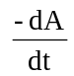 | (8.2)
Negative sign indicates that the concentration of drug A decreases with time t. As the reaction proceeds, the concentration of drug B increases and the rate of reaction can also be expressed as:
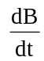 | (8.3)
Experimentally, the rate of reaction is determined by measuring the decrease in concentration of drug A with time t.
If C is the concentration of drug A, the rate of decrease in C of drug A as it is changed to B can be described by a general expression as a function of time t.
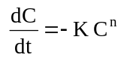 | (8.4)
where, K = rate constant
n = order of reaction
If n = 0, its a zero-order process, if n = 1, it is a first-order process and so on. The three commonly encountered rate processes in a physiological system are —
- Zero-order process
- First-order process
- Mixed-order process.
The pharmacokinetics of most drugs can be adequately described by zero- and first-order processes of which the latter are more important.

Zero-Order Kinetics (Constant Rate Processes)
If n = 0, equation 8.4 becomes:
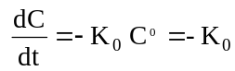 | (8.5)
where Ko = zero-order rate constant (in mg/min)
From equation 8.5, the zero-order process can be defined as the one whose rate is independent of the concentration of drug undergoing reaction i.e. the rate of reaction cannot be increased further by increasing the concentration of reactants.
Rearrangement of equation 8.5 yields:
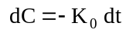 | (8.6)
Integration of equation 8.6 gives:
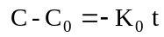 | (8.7)
or simply, 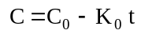 | (8.7)
where Co = concentration of drug at t = 0, and
C = concentration of drug yet to undergo reaction at time t.
Equation 8.7 is that of a straight line and states that the concentration of reactant decreases linearly with time. A plot of C versus t yields such a straight line having slope – Ko and y-intercept Co (Fig.8.2.).
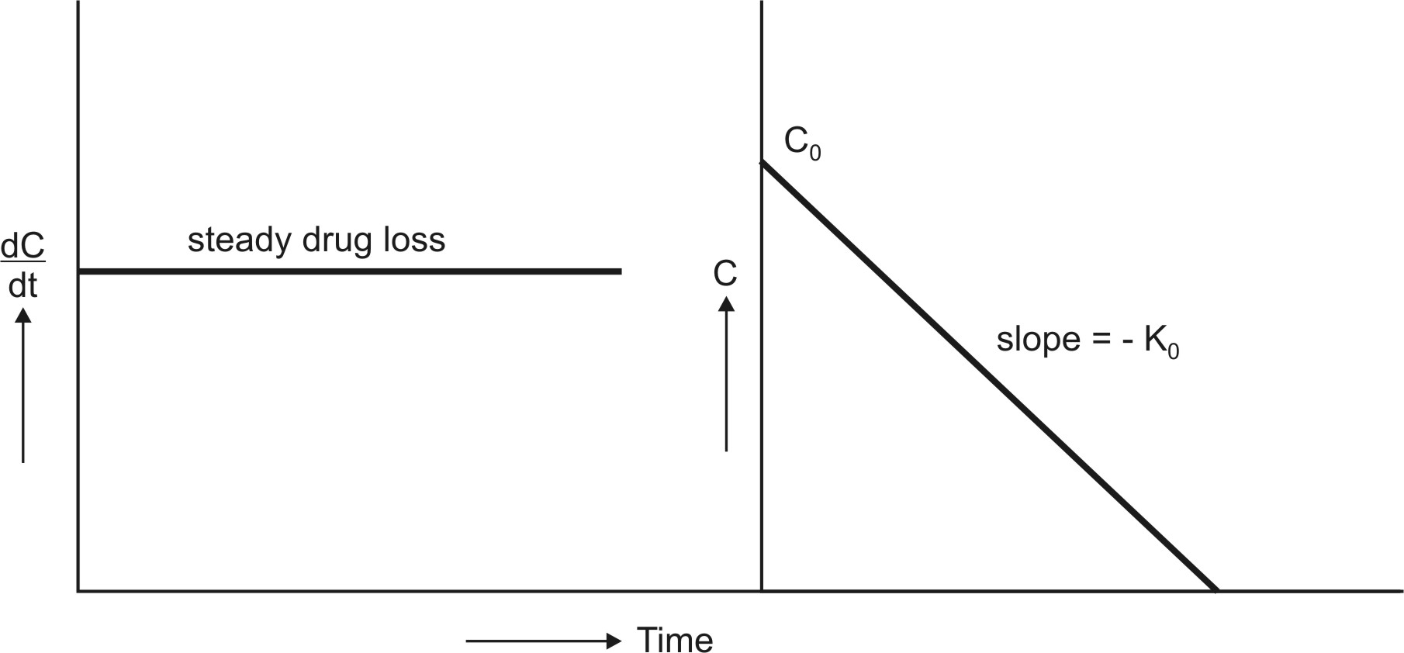
Fig. 8.2. Graphs of zero-order kinetics (equations 8.5 and 8.7)

Zero-Order Half-Life
Half-life (t½) or half-time is defined as the time period required for the concentration of drug to decrease by one-half. When t = t½, C = Co/2 and the equation 8.7 becomes:
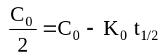 | (8.8)
Solving 8.8, we get:
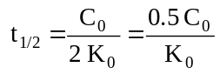 | (8.9)
Equation 8.9 shows that the t½ of a zero-order process is not constant but proportional to the initial concentration of drug Co and inversely proportional to the zero-order rate constant Ko. Since the zero-order t½ changes with the decline in drug concentration, it is of little practical importance. Zero-order equations do not require logarithmic transformations.
Examples of zero-order processes are –
1. Metabolism/protein-drug binding/enzyme or carrier-mediated transport under saturated conditions. The rate of metabolism, binding or transport of drug remains constant as long as its concentration is in excess of saturating concentration.
2. Administration of a drug as a constant rate i.v. infusion.
3. Controlled drug delivery such as that from i.m. implants or osmotic pumps.

First-Order Kinetics (Linear Kinetics)
If n = 1, equation 8.4 becomes:
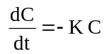 | (8.10)
where K = first-order rate constant (in time–1 or per hour)
From equation 8.10, it is clear that a first-order process is the one whose rate is directly proportional to the concentration of drug undergoing reaction i.e. greater the concentration, faster the reaction. It is because of such proportionality between rate of reaction and the concentration of drug that a first-order process is said to follow linear kinetics (Fig. 8.3.).
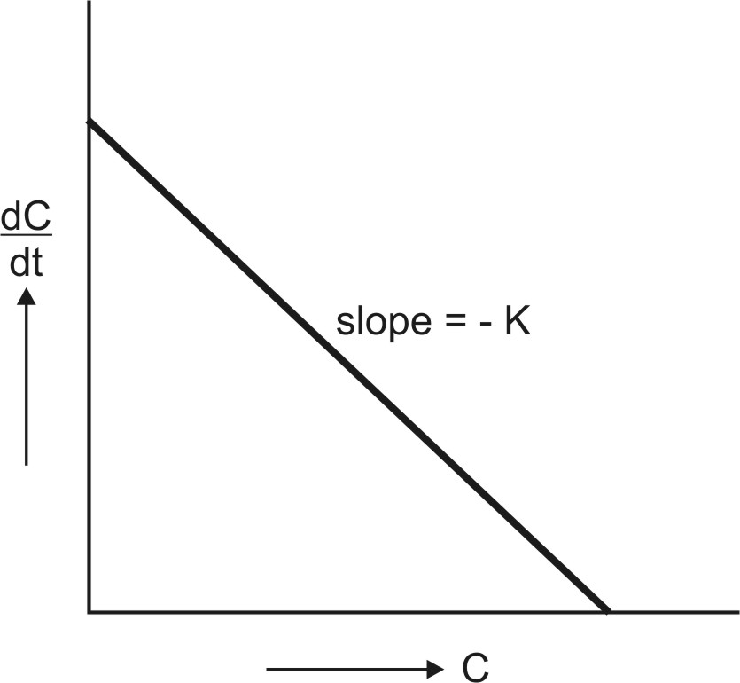
Fig. 8.3. Graph of first-order kinetics showing linear relationship between rate of reaction and concentration of drug (equation 8.10).
Rearrangement of equation 8.10 yields:
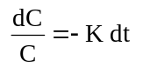 | (8.11)
Integration of equation 8.11 gives:
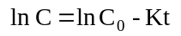 | (8.12)
Equation 8.12 can also be written in exponential form as:
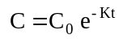 | (8.13)
where e = natural (Naperian) log base.
Since equation 8.13 has only one exponent, the first-order process is also called as monoexponential rate process. Thus, a first-order process is characterized by logarithmic or exponential kinetics i.e. a constant fraction of drug undergoes reaction per unit time.
Since ln = 2.303 log, equation 8.12 can be written as:
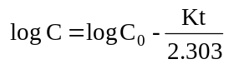 | (8.14)
or 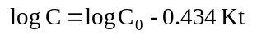 | (8.15)
A semilogarithmic plot of equation 8.14 yields a straight line with slope = –K/2.303 and y-intercept = log Co (Fig. 8.4.).

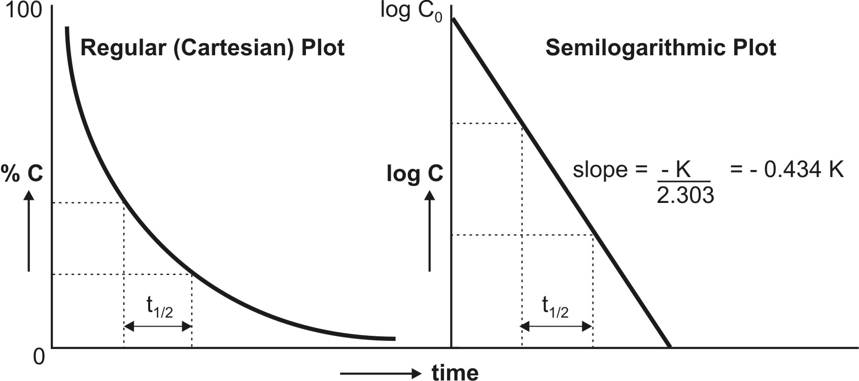
Fig. 8.4. Regular and semilog graphs of first-order kinetics

First-Order Half-Life
Substituting the value of C = Co/2 at t½ in equation 8.14 and solving it yields:
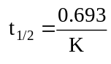 | (8.16)
Equation 8.16 shows that, in contrast to zero-order process, the half-life of a first-order process is a constant and independent of initial drug concentration i.e. irrespective of what the initial drug concentration is, the time required for the concentration to decrease by one-half remains the same (see Fig. 8.4.). The t½ of a first-order process is an important pharmacokinetic parameter.
Most pharmacokinetic processes viz. absorption, distribution and elimination follow first-order kinetics.

Mixed-Order Kinetics (Nonlinear Kinetics)
In some instances, the kinetics of a pharmacokinetic process changes from predominantly first-order to predominantly zero-order with increasing dose or chronic medication. A mixture of both first-order and zero-order kinetics is observed in such cases and therefore the process is said to follow mixed-order kinetics. Since deviations from an originally linear pharmacokinetic profile are observed, the rate process of such a drug is called as nonlinear kinetics. Mixed order kinetics is also termed as dose-dependent kinetics as it is observed at increased or multiple doses of some drugs. Nonlinearities in pharmacokinetics have been observed in –
- Drug absorption (e.g. vitamin C)
- Drug distribution (e.g. naproxen), and
- Drug elimination (e.g. riboflavin).
The phenomena is seen when a particular pharmacokinetic process involves presence of carriers or enzymes which are substrate specific and have definite capacities and can get saturated at high drug concentrations (i.e. capacity-limited). The kinetics of such capacity-limited processes can be described by the Michaelis-Menten kinetics.

Pharmacokinetic Parameters
The predictive capability of a pharmacokinetic model lies in the proper selection and development of mathematical functions called parameters that govern a pharmacokinetic process. In practice, pharmacokinetic parameters are determined experimentally from a set of drug concentrations collected over various times known as data. Parameters are also called as variables. Variables are of two types –
- Independent variables which are not affected by any other parameter, for example time.
- Dependent variables, which change as the independent variables change, for example, plasma drug concentration.
Certain points, which are important to note regarding application of parameters in pharmacokinetic studies, include –
  - The number of parameters needed to describe the pharmacokinetic model depends upon the complexity of the pharmacokinetic process and on the route of drug administration.
  - More the number of parameters more are the difficulties in accurate estimation of these parameters.
  - For the pharmacokinetic parameters to be valid, the number of data points should always exceed the number of parameters in the pharmacokinetic model.

PHARMACOKINETIC ANALYSIS OF MATHEMATICAL DATA :
PHARMACOKINETIC MODELS
Drug movement within the body is a complex process. The major objective is therefore to develop a generalized and simple approach to describe, analyse and interpret the data obtained during in vivo drug disposition studies. The two major approaches in the quantitative study of various kinetic processes of drug disposition in the body are (see Fig. 8.5) –
- Model approach, and
- Model-independent approach (also called as non-compartmental analysis).

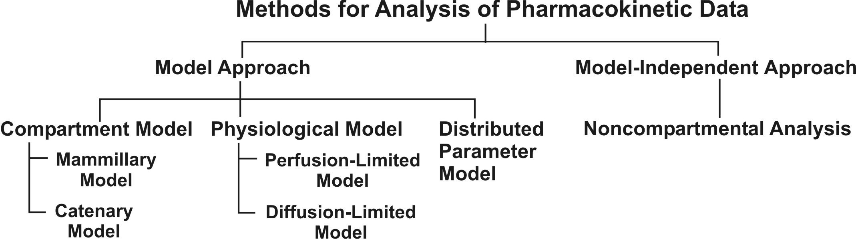
Fig. 8.5. Various approaches used for quantitative study of kinetic processes

Pharmacokinetic Model Approach
In this approach, models are used to describe changes in drug concentration in the body with time. A model is a hypothesis that employs mathematical terms to concisely describe quantitative relationships. Pharmacokinetic models provide concise means of expressing mathematically or quantitatively, the time course of drug(s) throughout the body and compute meaningful pharmacokinetic parameters.
Applications of Pharmacokinetic Models –
Pharmacokinetic models are useful in —
1. Characterizing the behaviour of drugs in patients.
2. Predicting the concentration of drug in various body fluids with any dosage regimen.
3. Predicting the multiple-dose concentration curves from single dose experiments.
4. Calculating the optimum dosage regimen for individual patients.
5. Evaluating the risk of toxicity with certain dosage regimens.
6. Correlating plasma drug concentration with pharmacological response.
7. Evaluating the bioequivalence/bioinequivalence between different formulations of the same drug.
8. Estimating the possibility of drug and/or metabolite(s) accumulation in the body.
9. Determining the influence of altered physiology/disease state on drug ADME.
10. Explaining drug interactions.
Caution must however be exercised in ensuring that the model fits the experimental data; otherwise, a new, more complex and suitable model may be proposed and tested.

Types of Pharmacokinetic Models
Pharmacokinetic models are of three different types –
- Compartment models – are also called as empirical models, and
- Physiological models – are realistic models.
- Distributed parameter models – are also realistic models.

Compartment Models
Compartmental analysis is the traditional and most commonly used approach to pharmacokinetic characterization of a drug. These models simply interpolate the experimental data and allow an empirical formula to estimate the drug concentration with time.
Since compartments are hypothetical in nature, compartment models are based on certain assumptions –
- The body is represented as a series of compartments arranged either in series or parallel to each other, that communicate reversibly with each other.
- Each compartment is not a real physiologic or anatomic region but a fictitious or virtual one and considered as a tissue or group of tissues that have similar drug distribution characteristics (similar blood flow and affinity). This assumption is necessary because if every organ, tissue or body fluid that can get equilibrated with the drug is considered as a separate compartment, the body will comprise of infinite number of compartments and mathematical description of such a model will be too complex.
- Within each compartment, the drug is considered to be rapidly and uniformly distributed i.e. the compartment is well-stirred.
- The rate of drug movement between compartments (i.e. entry and exit) is described by first-order kinetics.
- Rate constants are used to represent rate of entry into and exit from the compartment.
Depending upon whether the compartments are arranged parallel or in a series, compartment models are divided into two categories —
- Mammillary model
- Catenary model.

Mammillary Model
This model is the most common compartment model used in pharmacokinetics. It consists of one or more peripheral compartments connected to the central compartment in a manner similar to connection of satellites to a planet (i.e. they are joined parallel to the central compartment). The central compartment (or compartment 1) comprises of plasma and highly perfused tissues such as lungs, liver, kidneys, etc. which rapidly equilibrate with the drug. The drug is directly absorbed into this compartment (i.e. blood). Elimination too occurs from this compartment since the chief organs involved in drug elimination are liver and kidneys, the highly perfused tissues and therefore presumed to be rapidly accessible to drug in the systemic circulation. The peripheral compartments or tissue compartments (denoted by numbers 2, 3, etc.) are those with low vascularity and poor perfusion. Distribution of drugs to these compartments is through blood. Movement of drug between compartments is defined by characteristic first-order rate constants denoted by letter K (see Fig. 8.6). The subscript indicates the direction of drug movement; thus, K12 (K-one-two) refers to drug movement from compartment 1 to compartment 2 and reverse for K21.

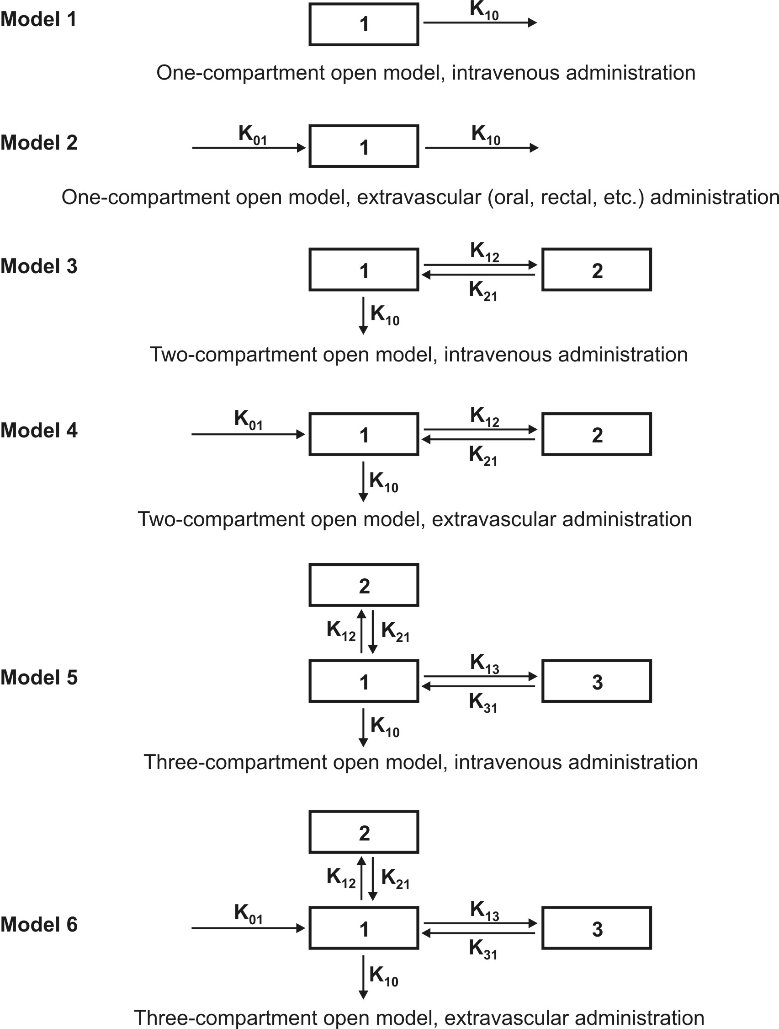
Fig. 8.6. Various mammillary compartment models. The rate constant K01 is basically Ka, the first-order absorption rate constant and K10 is KE, the first-order elimination rate constant.
The number of rate constants which will appear in a particular compartment model is given by R.
For intravenous administration, R = 2n – 1 | (8.17)
For extravascular administration, R = 2n | (8.18)
where n = number of compartments.

Catenary Model
In this model, the compartments are joined to one another in a series like compartments of a train (Fig. 8.7). This is however not observable physiologically/anatomically as the various organs are directly linked to the blood compartment. Hence this model is rarely used.
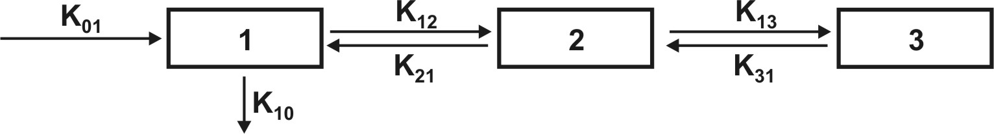
Fig. 8.7. A catenary model
The compartment modelling approach has several advantages and applications —
- It is a simple and flexible approach and thus widely used. Fundamentally, the principal use of this approach is to account for the mass balance of drug in plasma, drug in extravascular tissues and the amount of drug eliminated after its administration. It often serves as a “first-model”.
- It gives a visual representation of various rate processes involved in drug disposition.
- It shows how many rate constants are necessary to describe these processes.
- It enables the pharmacokineticist to write differential equations for each of the rate processes in order to describe drug-concentration changes in each compartment.
- It enables monitoring of drug concentration change with time with a limited amount of data. Only plasma concentration data or urinary excretion data is sufficient.
- It is useful in predicting drug concentration-time profile in both normal physiological and in pathological conditions.
- It is important in the development of dosage regimens.
- It is useful in relating plasma drug levels to therapeutic and toxic effects in the body.
- It is particularly useful when several therapeutic agents are compared. Clinically, drug data comparisons are based on compartment models.
- Its simplicity allows for easy tabulation of parameters such as V_{d}, t_{½}, etc.
Disadvantages of compartment modelling include —
- The compartments and parameters bear no relationship with the physiological functions or the anatomic structure of the species; several assumptions have to be made to facilitate data interpretation.
- Extensive efforts are required in the development of an exact model that predicts and describes correctly the ADME of a certain drug.
- The model is based on curve fitting of plasma concentration with complex multiexponential mathematical equations.
- The model may vary within a study population.
- The approach can be applied only to a specific drug under study.
- The drug behaviour within the body may fit different compartmental models depending upon the route of administration.
- Difficulties generally arise when using models to interpret the differences between results from human and animal experiments.
- Owing to their simplicity, compartmental models are often misunderstood, overstretched or even abused.

Because of the several drawbacks of and difficulties with the classical compartment modelling, newer approaches have been devised to study the time course of drugs in the body. They are — physiological models and noncompartmental methods.

Physiological Models
These models are also known as physiologically-based pharmacokinetic models (PB-PK models). They are drawn on the basis of known anatomic and physiological data and thus present a more realistic picture of drug disposition in various organs and tissues. The number of compartments to be included in the model depends upon the disposition characteristics of the drug. Organs or tissues such as bones that have no drug penetration are excluded. Since describing each organ/tissue with mathematic equations makes the model complex, tissues with similar perfusion properties are grouped into a single compartment. For example, lungs, liver, brain and kidney are grouped as rapidly equilibrating tissues (RET) while muscles and adipose as slowly equilibrating tissues (SET). Fig. 8.8 shows such a physiological model where the compartments are arranged in a series in a flow diagram.
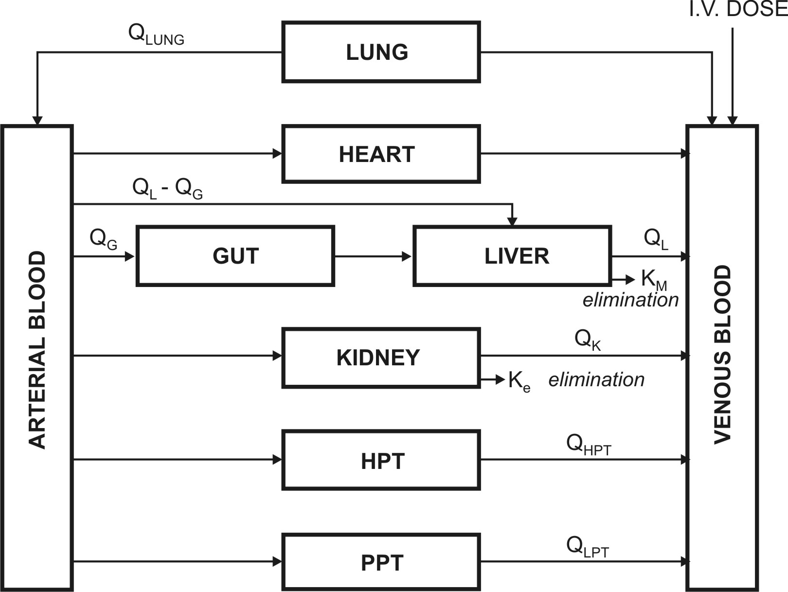
Fig. 8.8. Schematic representation of a physiological pharmacokinetic model. The term Q indicates blood flow rate to a body region. HPT stands for other highly perfused tissues and PPT for poorly perfused tissues. Km is rate constant for hepatic elimination and Ke is first-order rate constant for urinary excretion.

Since the rate of drug carried to a tissue organ and tissue drug uptake are dependent upon two major factors –
- Rate of blood flow to the organ, and
- Tissue/blood partition coefficient or diffusion coefficient of drug that governs its tissue permeability,
The physiological models are further categorized into two types –
- Blood flow rate-limited models – These models are more popular and commonly used than the second type, and are based on the assumption that the drug movement within a body region is much more rapid than its rate of delivery to that region by the perfusing blood. These models are therefore also called as perfusion rate-limited models. This assumption is however applicable only to the highly membrane permeable drugs i.e. low molecular weight, poorly ionised and highly lipophilic drugs, for example, thiopental, lidocaine, etc.
- Membrane permeation rate-limited models – These models are more complex and applicable to highly polar, ionised and charged drugs, in which case the cell membrane acts as a barrier for the drug that gradually permeates by diffusion. These models are therefore also called as diffusion-limited models. Owing to the time lag in equilibration between the blood and the tissue, equations for these models are very complicated.
Physiological modelling has several advantages over the conventional compartment modelling –
- Mathematical treatment is straightforward.
- Since it is a realistic approach, the model is suitable where tissue drug concentration and binding are known.
- Data fitting is not required since drug concentration in various body regions can be predicted on the basis of organ or tissue size, perfusion rate and experimentally determined tissue-to-plasma partition coefficient.
- The model gives exact description of drug concentration-time profile in any organ or tissue and thus better picture of drug distribution characteristics in the body.
- The influence of altered physiology or pathology on drug disposition can be easily predicted from changes in the various pharmacokinetic parameters since the parameters correspond to actual physiological and anatomic measures.
- The method is frequently used in animals because invasive methods can be used to collect tissue samples.
- Correlation of data in several animal species is possible and with some drugs, can be extrapolated to humans since tissue concentration of drugs is known.
- Mechanism of ADME of drug can be easily explained by this model.
Disadvantages of physiological modelling include —
- Obtaining the experimental data is a very exhaustive process.
- Most physiological models assume an average blood flow for individual subjects and hence prediction of individualized dosing is difficult.
- The number of data points is less than the pharmacokinetic parameters to be assessed.
- Monitoring of drug concentration in body is difficult since exhaustive data is required
Table 8.1 briefly compares features of compartment and physiological models.
TABLE 8.1. Comparison of features of compartment and physiological models
 | Compartment Modelling | Physiological Modelling
1. | Hypothetical/empirical approach – no relation with real physiology or anatomy | Realistic approach since it is based on physiological and anatomic information.
2. | Experimentally simple and flexible approach as far as data collection is concerned | Difficult experimentally since exhaustive data collection is required.
3. | Owing to its simplicity, it is widely used and is often the “first model”. | Less commonly used owing to complexity.
4. | Complex multiexponential mathematical treatment is necessary for curve fitting. | Mathematical treatment is straightforward.
5. | Data fitting is required for predicting drug concentration in a particular compartment. | Data fitting is not necessary since drug concentration in various tissues is practically determined.
6. | Used when there is little information about the tissues. | Used where tissue drug concentration and binding are known.
7. | Easy to monitor time course of drug in body with limited data. | Exhaustive data is required to monitor time course of drug in body.
8. | Extrapolation from data to humans and vice versa is not possible. | Extrapolation of animal data to humans is easy on the basis of tissue concentration of drugs.
9. | Mechanism of drug’s ADME cannot be explained. | Easy to explain drug’s ADME mechanisms.
10. | Effect of pathological condition on drug ADME cannot be determined. | Effect of pathology on drug ADME can be easily determined.
11. | Frequently used for data comparison of various drugs. | Less commonly used for data comparisons.

Distributed Parameter Model
This model is analogous to physiological model but has been designed to take into account –
- Variations in blood flow to an organ, and
- Variations in drug diffusion in an organ.
Such a model is thus specifically useful for assessing regional differences in drug concentrations in tumours or necrotic tissues.
The distributed parameter model differs from physiological models in that the mathematical equations are more complex and collection of drug concentration data is more difficult.

Noncompartmental Analysis
The noncompartmental analysis, also called as the model-independent method, does not require the assumption of specific compartment model. This method is, however, based on the assumption that the drugs or metabolites follow linear kinetics, and on this basis, this technique can be applied to any compartment model.
The noncompartmental approach, based on the statistical moments theory, involves collection of experimental data following a single dose of drug. If one considers the time course of drug concentration in plasma as a statistical distribution curve, then:
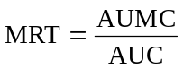 | (9.19)
where MRT = mean residence time
AUMC = area under the first-moment curve
AUC = area under the zero-moment curve
AUMC is obtained from a plot of product of plasma drug concentration and time (i.e. C.t) versus time t from zero to infinity (Fig. 8.9). Mathematically, it is expressed by equation:
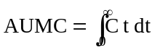 | (9.20)
AUC is obtained from a plot of plasma drug concentration versus time from zero to infinity. Mathematically, it is expressed by equation:
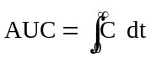 | (9.21)
Practically, the AUMC and AUC can be calculated from the respective graphs by the trapezoidal rule (the method involves dividing the curve by a series of vertical lines into a number of trapezoids, calculating separately the area of each trapezoid and adding them together).
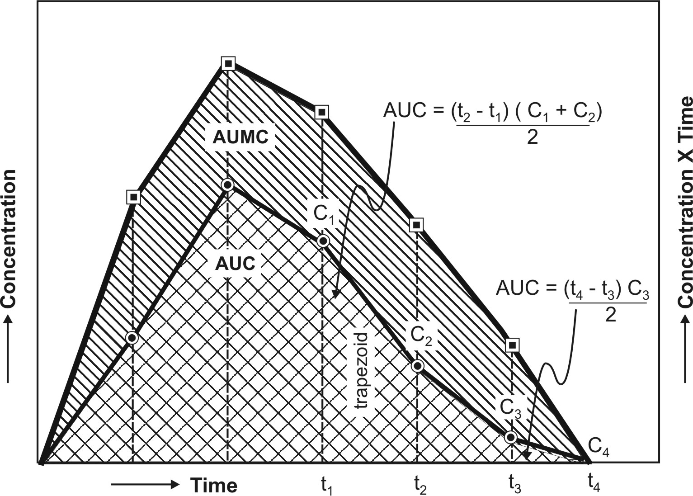
Fig. 8.9. AUC and AUMC plots
MRT is defined as the average amount of time spent by the drug in the body before being eliminated. In this sense, it is the statistical moment analogy of half-life, t½. In effect, MRT represents the time for 63.2% of the intravenous bolus dose to be eliminated. The values will always be greater when the drug is administered in a fashion other than i.v. bolus.
Applications of noncompartmental technique includes –
- It is widely used to estimate the important pharmacokinetic parameters like bioavailability, clearance and apparent volume of distribution.
- The method is also useful in determining half-life, rate of absorption and first-order absorption rate constant of the drug.
Advantages of noncompartmental method include —
1. Ease of derivation of pharmacokinetic parameters by simple algebraic equations.
2. The same mathematical treatment can be applied to almost any drug or metabolite provided they follow first-order kinetics.
3. A detailed description of drug disposition characteristics is not required.
Disadvantages of this method include –
- It provides limited information regarding the plasma drug concentration-time profile. More often, it deals with averages.
- The method does not adequately treat non-linear cases.

QUESTIONS
- In addition to mechanisms of drug ADME, explain how the knowledge about the kinetics of these processes is also important.
- Define pharmacokinetics. Name and define the three pharmacokinetic parameters that describe a typical plasma level-time curve.
- On what parameters/variables are Cmax, tmax and AUC dependent? What is the importance of these parameters in expressing pharmacodynamic behaviour of a drug?
- What are the various pharmacodynamic parameters?
- Quote examples of zero-order rate processes.
- In contrast to zero-order process, the half-life of a first-order process is considered to be an important pharmacokinetic parameter. Why?
- Why are first-order processes said to follow linear kinetics?
- What are mixed-order processes? By what other names such processes are identified? Quote examples of such processes.
- Define pharmacokinetic parameters? What are its various types? What are important considerations for parameters to be applicable in pharmacokinetic studies?
- What are the various approaches to quantitative study of kinetic processes of drug disposition?
- What are pharmacokinetic models? What is the importance and utility of developing such models? Discuss briefly the types of pharmacokinetic models.
- What assumptions are made in the development of compartment models? Discuss the applications, advantages and disadvantages of such an approach.
- In compartment modelling, elimination is presumed to occur from central compartment only. Why?
- Elaborate the types of compartment models. In comparison to a mammillary model, the catenary model is less useful. Explain.
- What are the advantages of physiological models over compartment models? On what assumptions are such models based?
- What are the various types of physiological models?
- What is the significance of distributed parameter model?
- On what theory is the noncompartmental analysis of pharmacokinetic data based? Discuss the merits and demerits of such an approach.
- The half-life for first-order photolysis of cefotaxime solution containing 150 mg drug is 50 minutes.
a. How long will it take for the drug to decompose to 20% of its original amount?
Answer : 116 minutes.
b. If one ml aliquot taken after 90 min of exposure to light was found to contain 0.43 mg of cefotaxime, what was the original volume of the solution?
Answer : 100 ml.
20. The following data for decomposition of two drugs, A and B are given in the table below :
Time (hours) Drug A (mg) Drug B (mg)
0.5 379 181.2
1.0 358 164.0
1.5 337 148.6
2.0 316 134.6
3.0 274 110.4
4.0 232 90.6
6.0 148 61.0
8.0 64 41.0
a. Determine (by plotting or otherwise) the rate of decomposition of both drugs.
Answer : Drug A = zero-order, and Drug B = first-order.
b. What is the rate constant for decomposition?
Answer : Drug A = 42 mg/hour, and Drug B = 0.198/hour.
c. What is their half-life?
Answer : Drug A = 4.76 hours, and Drug B = 3.5 hours.
d. What were the original amounts of drug before decomposition?
Answer : Drug A = 400 mg, and Drug B = 200 mg.
e. If the original quantities of drug taken were 800 mg for A and 400 mg for B then what will be their new half-lives?
Answer : Drug A = 9.52 hours, and Drug B = t½ will remain unchanged i.e. 3.5 hours.
f. Write equations for the line that best fits the experimental data for both drugs.
Answer: Drug A : C = 400 – 42t, and
Drug B : log C = log 200 – 0.198t/2.303.

